**B.Tech(ECE)**

**Task-6**

**Real-Time Use Case: Implementation of Digital Transformation in a Mid-Sized Retail Company**

**Scenario:**

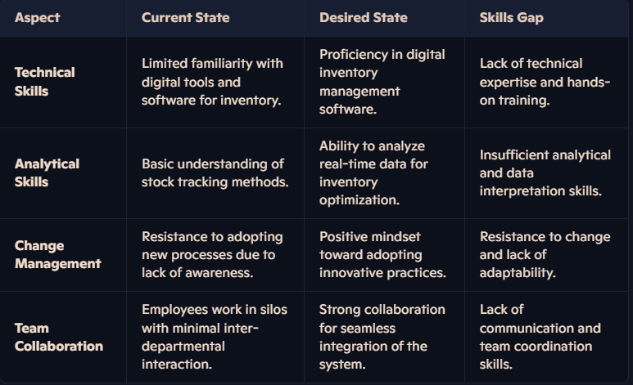The retail company is transitioning from traditional manual inventory management to a digital inventory management system. This system will enhance supply chain efficiency, track stock levels in real-time, and reduce errors. However, employees face challenges adapting to the new system, leading to a skills gap.

**Skills Developed through Design Thinking**

To address the gaps, **design thinking** can be applied. Here’s how its principles can develop relevant skills:

1. **Empathize:-**
   * Engage employees to understand their concerns and challenges with the new system.
   * *Skill Developed:* Active listening, empathy, and user-centric thinking.
2. **Defination:-**
   * Identify the core issues, such as fear of technology or lack of awareness, and define goals.
   * *Skill Developed:* Problem-solving and precision in defining issues.
3. **Ideas:-**
   * Brainstorm creative ideas like gamified training sessions or peer mentoring programs.
   * *Skill Developed:* Creativity, collaboration, and brainstorming techniques.
4. **Prototypes:-**
   * Develop small-scale pilot programs to train employees on the new system.
   * *Skill Developed:* Experimentation, iterative improvement, and technical hands-on training.
5. **Test:-**
   * *Skill Developed:* Feedback analysis, adaptability, and process improvement.